**Frameworks in Selenium**

1. Data Driven Framework
2. Keyword Driven Framework
3. Hybrid Framework
4. Modular Driver Framework
5. Test Driven Development Framework
6. Behavioural Driven Development Framework

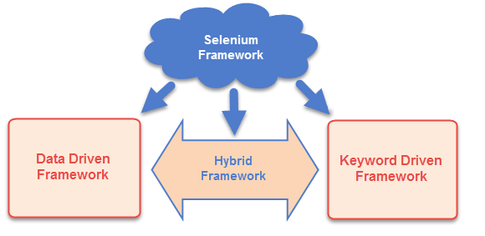

# Data Driven Framework

Executing same activity with multiple iteration with different dataset in each iteration

We will store the dataset in below ways

1. Excel File
2. Text File
3. Database

**Apache POI** – Poor Obfuscation Implementation

.xls – MS Excel 2007 - HSSFWorkbook

.xlsx – After MS Excel 2007 - XSSFWorkbook

Cell Type

1. Numeric
   1. Integer
   2. Float
2. String

# Keyword Driven Framework

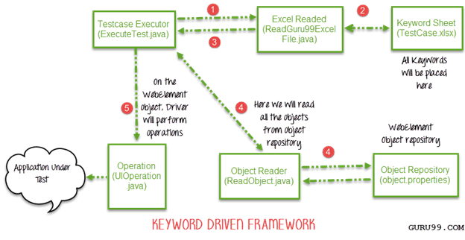

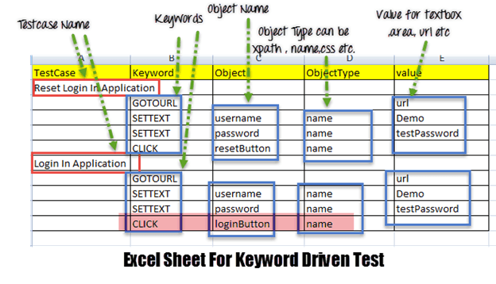

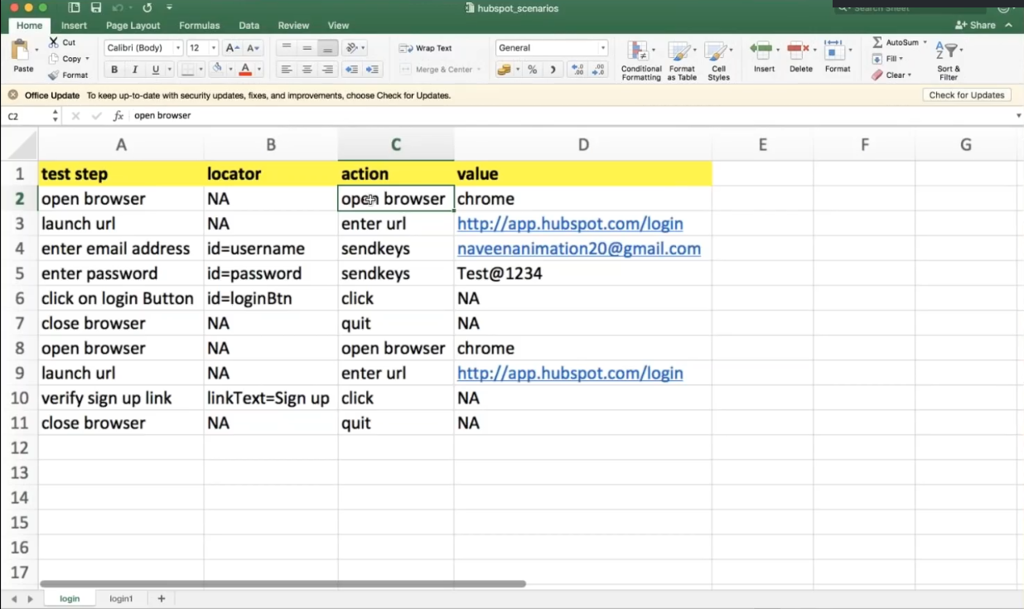

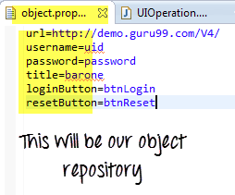

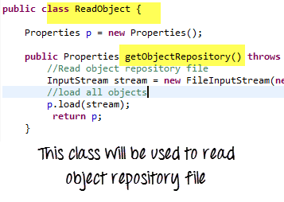

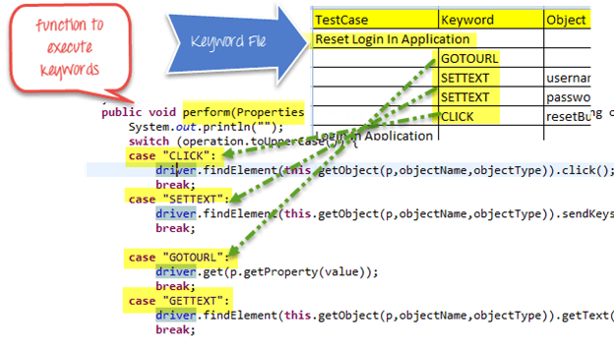

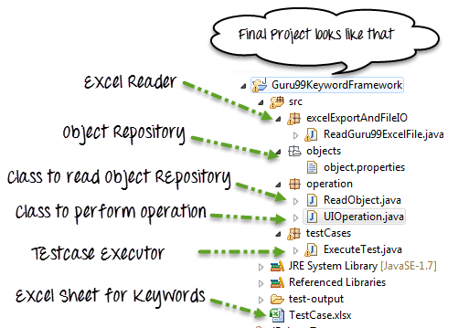

# Hybrid Framework

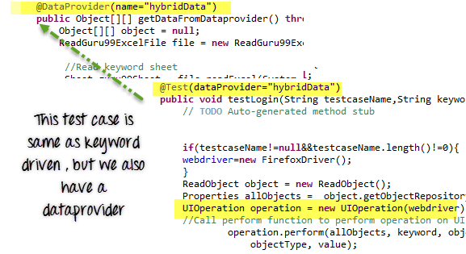

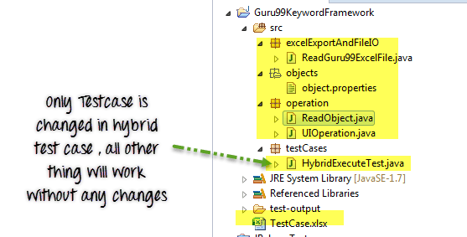

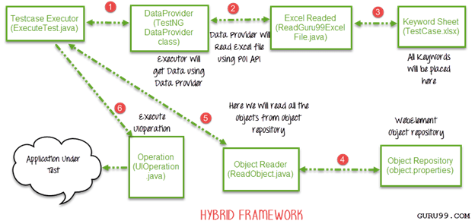

# Modular Driven Framework

# Test Driven Development

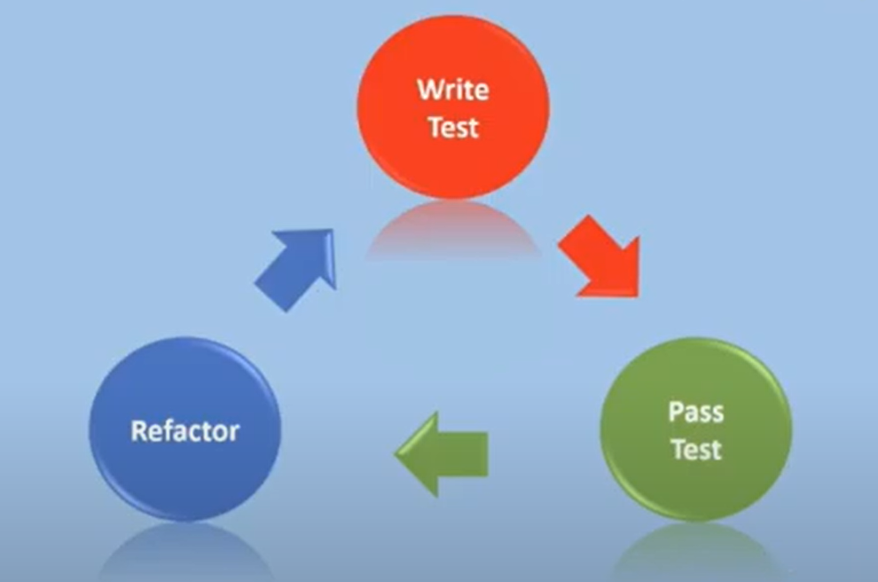

# Behavioural Driven Development Framework

It contains below three types of file

1. Feature file – Gherkin Language
2. Step Definition File
3. Test Runner file